1. What is the lecture mainly about?
2. Two theories about early astronomical concepts in the Americas
3. How different cultures created calendars based on astronomical observations
4. How astronomy helps to identify the functions of archaeological sites
5. Similar construction methods found at different archaeological sites in the Americas
6. What does the professor say about a round Mayan building?
7. It shows how the Maya were influenced by the builders of the medicine wheel
8. It has carvings showing the phases of the planet Venus
9. Its placement suggests that it served as a ceremonial site
10. It was used for observing the planet Venus
11. Why does the professor emphasize the size and location of the Bighorn Medicine Wheel?
12. To point out its similarity to structures in Mexico and Central America
13. To assert that its astronomical function should have been obvious
14. To show why early hypotheses about its use were unlikely
15. To explain which group of Native Americans probably built it
16. What did John Eddy find out about the Bighorn Medicine Wheel that classifies it as a type of observatory?
17. The wheel has the same number of spokes as a year has lunar months
18. The wheel indicates where the Sun rises or sets at certain times of the year
19. The wheel's circular shape symbolizes the Sun
20. The wheel's location provides an unobstructed view of the sky
21. What was a result of John Eddy's discovery that the Bighorn Medicine Wheel was a type of observatory?
22. It led to collaboration between astronomers and archaeologists on other archaeological sites.
23. It allowed archaeologists to accurately date the construction of the Bighorn Medicine Wheel.
24. It led to proof that the Native Americans in Wyoming had contact with the Maya
25. ted to proof that the planet Venus was important to many ancient cultures
26. Why does the professor say this.
27. To clarify the point the student is trying to make
28. To encourage students to make accurate observations when conducting research
29. To indicate that the term used by the student has more than one meaning
30. To point out that some ancient calendars are very accurate

CDCBAA

Listen to Part of a lecture in an archaeology class.

1. **What are the Venus tables?**
   1. **A book saying when Venus will rise and set**
2. **What is archeoastronomy?**
   1. **Archeoastronomy is a combination of archeological and astronomy, which gives archeologists an insight into the cultures, because it helps them to know the motivation of some buildings.**

It's well known among archaeologists that the civilizations in Central America and Mexico about 1,000 years ago, it's well known that they were accomplished astronomers.

**And how do we know this? Anyone? Joseph?**

**I know the Maya had a famous book and it has a chart in it saying when the planet Venus will rise and set. Right?**

That's something we now call the Venus tables.

So the Maya came up with an incredibly accurate table of the phases of the planet Venus.

But if you're not an astronomer, how are you going to understand it?

I know I couldn't.

I'm sure not many archaeologists could either.

That's why some archaeologists also study astronomy. Actually, it's an entire branch of archaeology called archaeoastronomy, combining archaeology and astronomy gives us insight into ancient cultures, because it helps us to understand part of their motivation as a culture. And the more we learn about ancient civilizations all over the world, the more we begin to see the importance of this field of research. 1-18’’

1. **What is another clue about the astronomy in Maya?** 
   1. **One building which is round, which looks like a modern observatory**
2. **What was the building used for?**
   1. **The building was used for track Venus**

**There are other clues that points to the importance of astronomy to the Maya, such as the placement of buildings, and and, how they were built.** In fact, there's a building. One of the few round buildings built by the Maya that archaeologists studied and were puzzled about for years. It looks remarkably like a modern observatory, but it wasn't until astronomers studied it, that we found that the building was set up to pretty accurately **track the planet Venus**.Q2 1’52’’

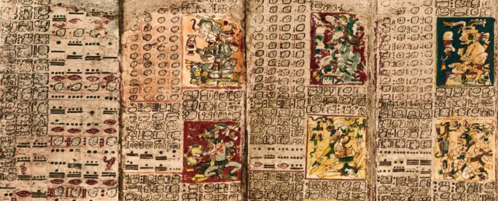

1. **Describe the big horn medicine wheel.** 
   1. **It is a wheel in Wyoming, which shapes like a huge wagon wheel that has many rocks arranged in a big circle.**

Now, there's a lesser known site where Archeoastronomy played a role right here in the United States. In what is now, Wyoming. It's called the big horn medicine wheel. The whole structure, it is shaped like a huge wagon wheel laid out on the ground. It's made of many rocks arranged in a big circle with a pile of rocks in the center and 28 lines of rocks radiating from the center like spokes. Q3 And naturally, we wanted to know why it was built, what purpose it served. We knew it was built by the people who lived in the plains. But we're not exactly sure when. It's estimated to be anywhere from 300 to 800 years old. 2’36’’

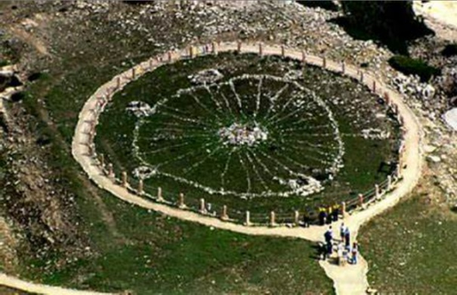

1. **What was the hypotheses about the function of the wheel?** 
   1. **Ceremony**
   2. **Hold a tent**
2. **What are the features of the wheels?**
   1. **High elevated**
   2. **Mainly covered with snow in months**
3. **What does the professor suggest about the hypotheses students raised?**
   1. **Not the right hypothesis**

So before archaeology revealed, what's probably the wheels function? What do you think some of the hypotheses were?

Maybe they thought it was built for some sort of ceremony.

Okay, good. That was one hypothesis.

Two things, though. It's at a **very** high elevation. Plus it's covered in snow about 8 months, a year. So it's not very accessible,

But that wouldn't necessarily rule it out.

No, you're right. It wouldn't still,

Oh. Uh, did they think the rocks were used to hold down the edges of a tent?

Well, a tent or a TP was another idea. But remember, it's high up in the mountains. And the whole thing is pretty large. Almost 25 meters across much bigger than the base of a tent would have been. 3’27’’

1. **What did John Eddie find about the wheel?**
   1. **Certain points on the wheel lined up with the points on horizon where sun rose ad set.**

**So who** finally figured out that it was related to astronomy?

While in the early 1970s, an astronomer learned about a different wheel, 5 or 600 kilometers south of the one in Wyoming. And how parts of that wheel lined up with the rising and setting sun on certain days of the year. The astronomer was John Eddie.

So John Eddie traveled to Wyoming to study the big horn medicine wheel. He studied the lines of Rocks. He took lots of measurements. And he found that when looking across the wheel, certain points on the wheel lined up with the points on the horizon where the sun rose and set. Q4 During the summer solstice, in in, June.

And there were other alignments to three very bright stars when they appeared in the sky for the first time each year, 28 days apart from each other, same as the lunar month. 4’21’’

1. **What’s the meaning of the discovery?**
   1. **It promotes more often cooperation between archeologists and astronomers**

So what does this tell us?

It was used as a calendar. Well, A calendar. I think an astronomical tool, an observatory that helped make a calendar would be more accurate.Q6 But before John Eddie's research, no one ever studied in that context, they never even considered it. The Discovery prompted archaeologists and astronomers to join forces more often. Q5

Together, we've studied more structures in the Americas, other stone circles, wooden structures, earth mounds. And we've learned that many were used for astronomical observations. And in examining those observations, we've really expanded our understanding of the people who lived in the America's hundreds of years ago. 5’09’’